CV

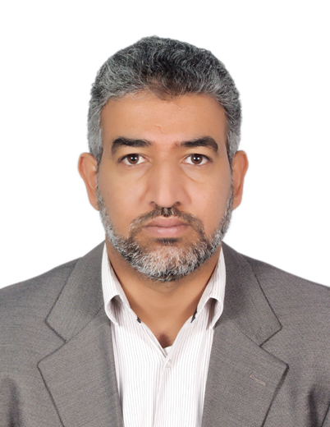

PERSONAL INFORMATION

- Name : Ali Odeh Hammoud Alidmat

- Father’s name: Odeh

- Mother’s name: Inzaileh

- Gender: Male

- Date of birth: 1-4-1977

- Place of birth: Mafraq- Jordan

- Nationality : Jordanian

- Mailing address: Department of English, Aljouf University, AlJouf
Province, Sakaka, PO Box: 2014, Saudi Arabia .

- Mobile number: 00962796041937

- Email Id: Abuyazeed1977@yahoo.com
- Occupation (Status and Institution): Lecturer,
Department of English,
Aljouf University, Saudi Arabia
- Major field of specialization : English

Academic qualifications:

College/University attended | Year | Degree earned | Major field
Yarmouk University , Jordan | 2004 | MA | English
Yarmouk University , Jordan | 1999 | BA | English
Ministry of Education, Jordan | 1995 | Secondary School Certificate | Literary subjects

Professional employment history:

From | To | Position | Institution
2015 | Present | Lecturer | Alblqa Applied University  Aqapa College
2009 | 2014 | Lecturer at the Department of English | Anjou University- Saudi Arabia
2004 | 2009 | Lecturer at the Department of English | King Khalid University- Saudi Arabia
1999 | 2004 | English Language Teacher | Ministry of Education- Jordan

M.A THESIS
The subject of my M.A thesis is on the translatability of the Bedouin dialect into English, it is entitled “The Translatability of the Bedouin Dialect in Abdellrahman Munif’s Novel Cities of Salt: A case study.

Publication:
- “A study on the usefulness of Audio- Visual Aids in EFL Classrooms: Implications for effective instruction,” 2013, International Journal of Higher Education.( published)
2- Matters Arising in Development of Critical Thinking Skills through Writing Tasks: Case Study of Maritime English for Special Purposes Students at Aqaba College, Al-Balqa Applied University, Jordan

