

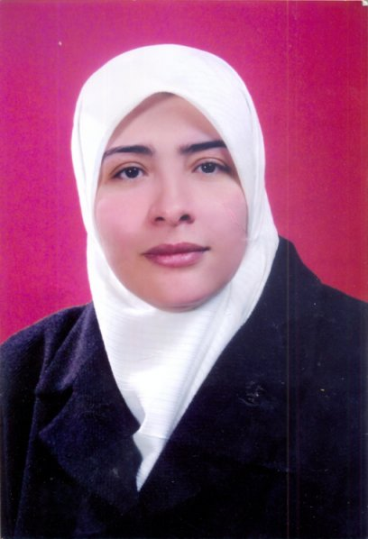

**Photo**

**Al-Balq`a Applied Univesity**

**CURRICULUM VITAE**

**1 -Personal Information:**

|  |  |  |  |
| --- | --- | --- | --- |
| **29628** | **Employee Number** | **Falastine Rafiq Salem Hamdan** | **Name** |
| **Assistant Professor** | | | **Academic rank** |
| **Applied Science** | **Department** | **Irbid College** | **Place of Work** |
| **Adult Health Nursing** | **Area of specialization** | **Nursing** | **Major** |
| **0775287078** | **Mobile Phone** | **7273197** | **Work Phone** |
| [**Falsteen.hamdan@gmail.com**](mailto:Falsteen.hamdan@gmail.com) | | | **E-mail** |

**2- Educational History:**

|  |  |  |  |  |
| --- | --- | --- | --- | --- |
| **Date of graduation** | **Major** | **Country** | **Name of the University** | **Degree** |
| 1998 | Nursing | Jordan | Jordan University of Science & Technology (JUST) | B.A |
| 2000 | Nursing/ Adult health nursing | Jordan | Jordan University of Science & Technology (JUST) | M.A |
| 2010 | Nursing/Adult health nursing | Jordan | Jordan University (JU) | Ph.D. |

**3- Academic Record**

| **Duration** | | **Place of work** | **Occupation** |
| --- | --- | --- | --- |
| **To** | **From** |
| Present | 2002 | Al-Balqa Applied University | Nursing Lecturer |
| 6/2015 | 8/ 2014 | Taibah University | Nursing Lecturer |
| -09/2002 | 10/1999 | Ministry of Health (Nusyba Al- Mazeniaha Collage of Nursing) | Nursing Lecturer |
| 09/2002 | 10/ 1994 | Princess Basma Hospital CCU & Surgical Departments | Registered Nurse |

**4- publications:**

|  |  |  |  |  |  |
| --- | --- | --- | --- | --- | --- |
| **Date** | **Volume** | **Issue Number** | **Country** | **place of Publication** | **Research Title** |
| 2015 | 11 | 33 |  | European Scientific Journal | THE ROLE OF THE NURSES IN HEALTH PROMOTION FROM THE VIEW POINT OF PATIENTS AT KING ABDULLAH HOSPITAL IN IRBID |
| 30/5/2015 | Volum.3 | (3) |  | Global journal of medical , physical and health education | Jordanian nurses and acute myocardial infarction patients’ perceptions about learning needs |
| 2014 | (2)(2). | 3 |  | International Journal of Advanced Nursing Studies | .The Effect of Health Education Programs for Parents about breakfast on Students' Breakfast and their Academic Achievement in the north of Jordan. |
| 2014 | (17) September | 8 |  | Advances in Environmental Biology | Sociodemoraghic, Clinical and Contextual Factors of Delay in Seeking Medical Care of Jordanian Patients with Acute Myocardial Infarction(AMI) |
| Med J 2010 | (4) | 44 | Jordan | Jordanian Medical Journal (JMJ). | Delay Times and Decision making Processes in Acute Myocardial Infarction: A Qualitative Literature Review".J |
| 18 OCT 2010 | 2 | 25 |  | Scandinavian Journal of Caring Sciences | Who uses nursing theory? A univariate descriptive analysis of five years’ research articles |

**5- Conferences, Seminars and Workshops:**

|  |  |  |  |
| --- | --- | --- | --- |
| **Date** | **Location** | **Research Title** | **Conference Name** |
| " April 23-24- 2013 | Amman/ Jordan | " Predictors of Delay in Seeking Medical Care in Jordanian Patients with Acute Myocardial Infarction | the Fourth International JNC Conference **The Tipping Point: Creative Solutions to Health and Nursing Challenges** |
| April 27-28 2010 | Amman/ Jordan | "Delay Times in Acute Myocardial Infarction; Patients' Experiences and Decision Making Processes: A Qualitative Literature Review | Third International JNC Conference The Heart of the Matter: Relevance of Nursing Responsiveness " موائمة استجابة التمريض للواقع |
| April 23rd -24th 2008 | Amman/ Jordan | "Delay Times in Acute Myocardial Infarction; Patients' Experiences and Decision Making Processes: A Quantitative Literature Review | the Second JNC International The Less Traveled Road: Search for New Realities" |
| 18/10/2014 | Saudi Arabia/Taibah Unevirsity | Cardiopulmonary resuscitation/ PLS/ | Certificate/ Saudi Heart Association |
| 19-21/10/2014 | Saudi Arabia/Taibah Unevirsity | Preparing Academic members | Workshop/ Taibah Unevirsity |
| 19/5/2010 | Ajloun College | The Role of Applied Science in Community Development | Wokshop/Ajloun College |
| 22-23/2/2006 | Amman/Jordan | Promoting and Enhancing the Quality of Nursing | Workshop /Al-Hussien Fund for Excellence |

**6- Published Books**

| **Number of pages** | **Year of publication** | **Place of Publication** | **Book Title** |
| --- | --- | --- | --- |
|  |  |  |  |

**7- Grants and awards:**

|  |  |  |
| --- | --- | --- |
| **Date** | **Institution** | **Award Title** |
|  |  |  |

**8- Patents:**

| **Date** | **Registration Authority** | **Paten Title** |
| --- | --- | --- |
|  |  |  |

**9- Courses:**

|  |  |  |
| --- | --- | --- |
| **Institution** | **Academic year** | **Courses Title** |
| Irbid National University | Ist semester 2013/2014 | Mental Health Nursing  Health Assessment |
| Irbid National University | 2ed semester 2013/2014 | Fundamental of Nursing/ clinical |
| Irbid National University | 2014/2015 | Palliative nursing care  Adult health nursing  Adult health nursing/clinical |
| Ajloun and Irbid colleges/Al- Balqa Applied University | 2002-2015 | Lecturing all nursing courses |

**10- Supervision of these Dissertations:**

|  |  |  |
| --- | --- | --- |
| **Date** | **Degree Institution** | **Title** |
|  |  |  |

**11- Community Service:**

| **Date** | **Type of Participation** | **Participation** |
| --- | --- | --- |
| **11-13/11/2014** | **Breast Exam** | Participation in the national campaign for Breast cancer in A-lmadina Al-monawra/Saudi Arabia |
| **2013, 2014** | **Lectures/presenter** | School health and women health lectures |
|  |  |  |